**Practical No.06**

**PHP and MongoDB**

**1] Copy the php mongo driver in C:\xampp\php\ext\php_mongo-1.6.8-5.6-vc11.dll**

**2] In xamp\apache server\ config\php(ini) file**

**3] find extetsion and add extension=php_mongo-1.6.8-5.6-vc11.dll**

**4] save and restart apache server.**

**A] Connecting PHP with MongoDB and inserting, retrieving, updating and deleting.**

**1] Make connection and select database:**

**Code:**

<?php

$m=new MongoClient();

echo "Connection database successfully.\n";

$db=$m->mydb;

echo "Database mydb selected"

?>

**Output:**

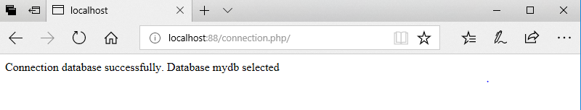



**2] Create collection:**

**Code:**

<?php

$m=new MongoClient();

echo "Connection database successfully.\n";

$db=$m->mydb;

echo "\n Database mydb selected.";

$Collection=$db->CreateCollection("Mycol");

echo "\n collection created successfully";

?>

**Output:**

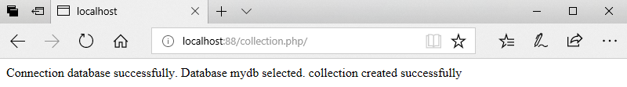



**3] Insert Document:**

**Code:**

<?php

$m=new MongoClient();

echo "Connection database successfully.<br>";

$db=$m->mydb;

echo "Database mydb selected successfully.<br>";

$Collection=$db->mycol;

echo "Collection selected successfully.<br>";

$document=array('Roll NO' =>101 ,'Name' =>'ABC','Marks'=>75);

$Collection->insert($document);

echo "Document inserted successfully";

?>

**Output:**

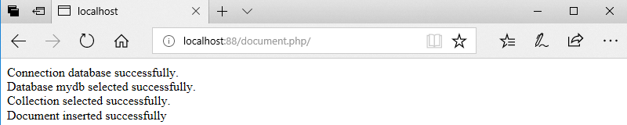

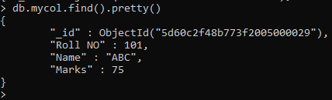

**4] Retriving Document:**

**Code:**

<?php

$m = new MongoClient();

echo "Connection to database successfully.<br>";

$db = $m->mydb;

echo "Database mydb selected.<br>";

$Collection = $db->mycol;

echo "Collection selected succsessfully.<br>";

$cursor=$Collection->find();

foreach ($cursor as $document) {

echo $document['Roll NO']."\n";

}

?>

**Output:**

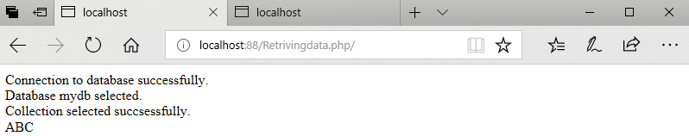



**5] Update a Document:**

**Code:**

<?php

$m = new MongoClient();

echo "Connection to database successfully.<br>";

$db = $m->mydb;

echo "Database mydb selected.<br>";

$Collection = $db->mycol;

echo "Collection selected succsessfully.<br>";

$Collection->update(array("Name"=>"ABC"),array('$set'=>array("Name"=>"SK")));

echo "Document updated successfully.<br>";

$cursor=$Collection->find();

foreach ($cursor as $document) {

echo $document['Name']."\n";

}

?>

**Output:**

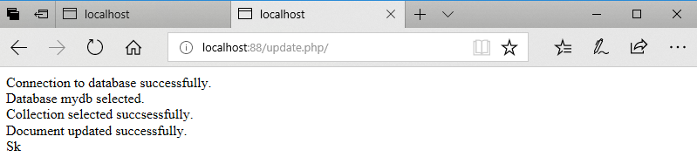

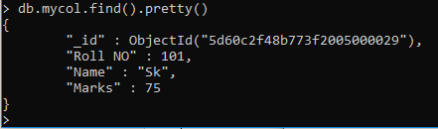

**6] Delete a Document:**

**Code:**

<?php

$m = new MongoClient();

echo "Connection to database successfully.<br>";

$db = $m->mydb;

echo "Database mydb selected.<br>";

$Collection = $db->mycol;

echo "Collection selected succsessfully.<br>";

$Collection->remove(array('Name'=>"Sk"));

echo "Documents deleted successfully.<br>";

$cursor = $Collection->find();

foreach ($cursor as $document) {

echo $document["Name"] . "\n";

}

?>

**Output:**

